**A report on “Employee Burnout”**

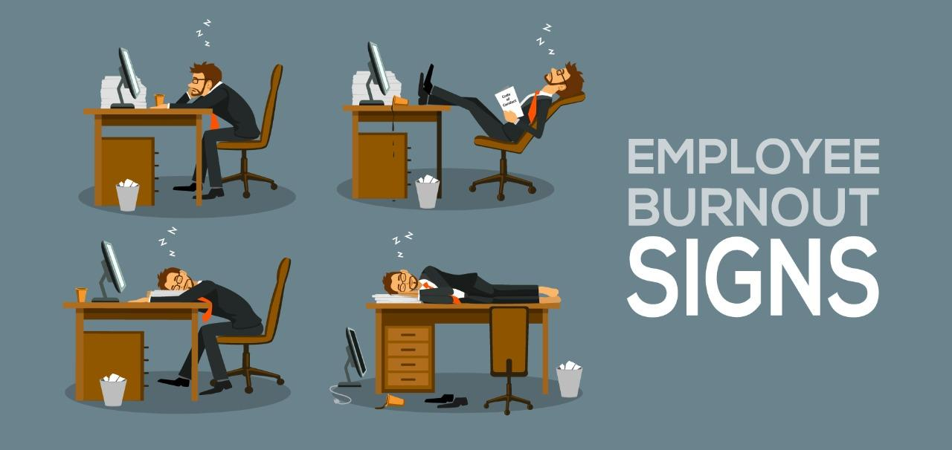

Prepared for : Term Work

Date of Submission : 05 December, 2022

A report submitted in partial fulfilment of the subject “Professional Business communication” to the Subject in-charge, Ms. Shreya Mishra,

| NAME | SAPID | SIGNATURE |
| --- | --- | --- |
| Akshat parekh | 60004200116 |  |
| Kevin Haria | 60004200117 |  |
| Riya Shah | 60004200118 |  |
| Mihir Shinde | 60004200122 |  |
| Bhargavee Chavarkar | 60004200124 |  |
| Ayush Jain | 60004200132 |  |
| Simran Bhardan | 60004200135 |  |
| Khushi Gupta | 60004200136 |  |
| Dhruv Gandhi | 60004200133 |  |

Prepared for : Term Work

Date of Submission : 05 December, 2022

# **TABLE OF CONTENT**

# 

# *Preface I*

# *Acknowledgement II*

# *Abstract III*

# 

# **Chapter 1:** Introduction 1

# 

# **Chapter 2:** Reasons 3

# 

# **Chapter 3:** Effects 6

# 

# **Chapter 4:** Case Studies

# 4.1 Case Study on Bank 8

4.1.1 Methods and Procedures

4.1.2 Results

4.1.3 Discussions

4.1.4 Conclusion

4.1.5 Recommendation

4.1.6 The need to make use of Mindfulness

4.2 Case Study on IT Sector 17

4.2.1 Introduction

4.2.2 Is burnout common in the tech industry?

4.2.3 What Is Causing Employee Burnout in the IT industry?

4.2.4 Signs of burnout

4.2.5 The Consequences of Burnout in IT sector

4.2.6 How can we reduce employee burnout in the IT sector?

4.2.7 Summary

4.3 Case Study on Hospital 24

4.3.1 Introduction

4.3.2 Pandemics

4.3.3 Specific occupations at risk

4.3.4 Identification

4.3.5 Prevention and Treatment

4.3.6 The Future

4.3.7 Summary

**Chapter 5:**  Avoidance 31

Survey Analysis 34

Conclusion 37

Appendix 38

References 39

Glossary 40

# 

# 

# 

# 

# 

# 

# 

# **PREFACE**

We are happy to present this report on ‘Employee Burnout’ which has been prepared keeping in mind everyone’s interests and spectrum of knowledge. The report has been segregated into different chapters for the purpose of better comprehension and for the sake of simplicity. All the aspects of Employee Burnout have been explained in this report. It will help you understand how work-life balance is important and work-stress should not be neglected. We could have missed out some aspect in the topic but we hope that you find the report satisfactory. We tend to think of burnout as an individual problem, solvable by “learning to say no,” more yoga, better breathing techniques, practising resilience — the self-help list goes on. But [evidence is mounting](https://jamanetwork.com/journals/jama/fullarticle/2730614) that applying personal, band-aid solutions to an epic and rapidly evolving workplace phenomenon may be harming, not helping, the battle. With [“burnout” now officially recognized by the World Health Organization (WHO)](https://www.who.int/mental_health/evidence/burn-out/en/), the responsibility for managing it has shifted away from the individual and towards the organisation. Leaders take note: It’s now on *you* to build a burnout strategy.

# **ACKNOWLEDGEMENT**

The completion of this report could not have been possible without the participation and assistance of many people. Their contributions are sincerely appreciated and gratefully acknowledged.

We would like to express our sincere gratitude to our Respected Principal Sir, Dr. Hari Vasudevan and our Head of Department, Dr. Meera Narvekar for giving us support and enlightening us whenever we felt immovable.

We would like to express our profound gratitude and deep regards to our professor Prof.Shreya Mishra for giving us an opportunity to make a report on the topic “Employee Burnout” during the course of which we came across several facts that we weren't cognizant of. Without their kind direction and invaluable guidance, this would not have been a little success. In every phase of this task, their supervision shaped the report to be successfully completed.

We would also like to thank all the people who took an effort and went ahead and helped us during the course of this report by sincerely giving us their point of views and feedback via our survey.

We thank you.

# **ABSTRACT**

Burnout is a specific reaction of employees to job-stress, which manifests itself in the dimensions of emotional exhaustion, depersonalization (cynicism), and reduced personal accomplishment. Literature has already identified a large number of personal, organisational, and situational factors that may participate in the development or exacerbation of burnout. Even if burnout is mostly produced by different aspects of job-stress, its effects are not limited to the individual’s professional life. Burnout may additionally impact the person’s physical, emotional, and social life, too. Consequently, the design of efficient prevention and intervention programs are crucial not only for reducing burnout produced financial losses, but also to optimise the employees’ quality of life in ensemble. A term once reserved for healthcare workers who put in too many hours in high-stress jobs, “employee burnout” has now extended across industries and applies to all types of workers. Recently, the World Health Organisation officially classified burnout as a syndrome related to “chronic workplace stress that has not been successfully managed.”Observant leaders recognise that the current workforce is shouldering unprecedented demands. Now, more than ever, employees are expected to do more with less. Burnout is a real and present threat. After decades of being isolated to a small number of specific industries, many global organisations now realise that burnout is more pervasive and may be curbing their ability to succeed. Burnout not only affects the organisation and its people, but also the larger communities to which they belong. This precipitates a wider ripple effect of elevated anxiety levels and other psychological and physiological health issues. Organisations need to measure burnout, identify workplace cultural preconditions that foster burnout, and take active steps to mitigate it. Burnout can be measured through the following framework: Employee burnout is costly: burnout is estimated to be attributed to 120,000 deaths per year and $190 billion in healthcare spending. This doesn’t include burnout’s toll on decreased productivity, an increase in errors, absenteeism, and other organisational costs.3 Companies with moderate-to-severe burnout have a 376% decrease in the odds of having highly engaged employees, 87% decrease in likelihood to stay, 22% decreased work output, and 41% decrease in the perception of the employee experience. Moreover, the effect of burnout goes home with employees: Gallup reports burned-out employees are 23% more likely to visit the emergency room.4 Another study5 saw major health risks as a result of burnout: Type 2 diabetes, coronary heart disease, gastrointestinal issues, high cholesterol, and even death for employees younger than 45.

**INTRODUCTION**

Work holds a central place in modern life. It gives us one of the basic means for living (work as a job undertaken for financial reward). To some it may become a significant source of success, achievement, and satisfaction (work as career), while for others it may represent intrinsic motivation, purpose, and a higher meaning in life (work as calling), etc. Specific to Western societies is that the majority of the working class spends more of its waking time working and preparing for work than doing anything else. Behind these apparently positive aspects however (money, recognition, meaning-vocation), the situation is not always so rosy. The relationship between the individual and his/her work seems to be much more complex and, in many cases, to some people it may conceal serious traps. One of these pitfalls is represented by the phenomenon known since the 70s under the term of burnout.

Burnout may be produced by the individuals prolonged inability to adapt to job stressors, however its effects do not exclusively impact the individuals professional life and performances. Individuals suffering from burnout cannot shed the inconveniences caused by this disorder at the entrance to their private life - symptoms of burnout may permeate other aspects of functioning as well. As the effects of burnout spread over and deteriorate the person's personal life, the repercussions will probably be felt at the individual's workplace as well. Thus a negative spiral may develop that, if unresolved, could exacerbate malfunctioning. Research has evinced a strong association between burnout symptoms and psychological, physiological, social, etc. functioning. High levels of burnout usually correlate with alcoholism, mental illness (high levels of depression and anxiety), suicide, cardiovascular problems, alienation from others, self-neglect, etc.

Since the psychosocial dimensions of the relationship between work and individuals have significantly changed in the last decades, the quality of work-milieu has also changed, seriously impacting the quality of work and the quality of the employees lives. Intense market competition, constantly increasing needs of the consumers, accelerated development of technology, etc. are all characteristics of the present economy. These demands have induced changes in previous work-conditions, imposing a heavy supplementary load on employees resources, by requiring excessive flexibility, increased responsibilities, permanent need to learn and incessantly reorient professionally, job-insecurity, and the increased need to dissolve the thin lines that separate professional from private life. Thus, this complex interplay between the personal and professional life deserves increased attention especially if we consider the general tendency of dramatic increase in the number of individuals suffering from mental disorders. The report focuses on the succinct presentation of the increasingly spreading disorder of burnout, followed by the succinct description of most important risk factors, most frequent consequences, and the brief discussion of intervention programs, as well as by burnout's hypothetical antipode work engagement.

In terms of the risk factors of work-related burnout, particularly at a time when the world was not drastically affected by a global crisis, such as the COVID-19 pandemic, many have been suggested and studied . As summarised by Aydemir and Icelli, the risk factors for work-related burnout can be broadly classified into environmental and personal factors. The environmental factors include, but are not limited to, the physical environment, work overload, workplace unfairness and bullying, lack of control over work, and insufficient compensation or reward. For personal factors, some demographics and individual personalities may also contribute to burnout among workers. Genetics was also proposed to play a role in the burnout syndrome of workers. Evidence on the association between gene variants and burnout is not strong, but is worth further exploration. More recent studies have seen a gradual shift from the risk factors to protective factors in the workplace. For example, in the work environment Anyfantis et al. found that interpersonal relationships and having a degree of freedom in work were protective against burnout among labour inspectors. Hämmig also acknowledged that support from the direct supervisor in case of a problem at work and home could be a protective factor. Personal factors, such as psychological resources, self-esteem, and the meaningfulness of work were also negatively associated with burnout at work.

In the past two years, due to the global crisis of the COVID-19 pandemic, the work life of the working population in many countries has changed drastically. For some, the pandemic has caused the cessation of work because of the closure of businesses and redundancy, or as a result of restructuring and downsizing. Some workers may experience a change in their status, position, or a total departure from the industry in which they have been working for many years. The changes in the macro- and micro-work environments may pose new challenges to workers and affect modes of operation in many different industries. As a result, different influencing factors of work-related burnout may arise under this unusual circumstance. As part of a government-funded intervention program for enhancing mental health and wellbeing in the workplace, data on personal and environmental variables were collected at the baseline, post-intervention, and 3-month follow-up. The current study aims to report both environmental and personal factors that are associated with work-related burnout in a population of corporate employees who managed to retain their jobs amidst the global crisis.

# **REASONS**

Employee burnouts are increasing day by day but it has more than one reason leading to it. Here are some major reasons leading to employee burnouts:“Burnout is a complex constellation of poor workplace practices and policies, antiquated institutional legacies, roles and personalities at higher risk, and system societal issues that have been unchanged, plaguing us for too long,” writes Moss.

Basic things must be in place for people to thrive at work—what she calls “good hygiene.” This includes paying people what they’re worth (and on time), making sure they are physically and mentally safe, and providing the tools and resources they need to do their jobs. It also means being sure that discriminatory practices are not part of your workplace culture. Beyond that, there are six main reasons people tend to burn out at work, she writes—each of them with a potential workplace solution:

1. Job Scope Creep

If you compare the job description on a listing to the work duties that your employees have a year later, do they vary significantly? Scope creep can happen as business needs change and employees become more familiar with the organisation. However, if someone is brought onto a team for their specialty but ends up getting bogged down with administrative paperwork, they may not appreciate the shift.

## Lack of Engagement

Employees [become disengaged](http://news.gallup.com/topic/employee_engagement.aspx) with their work for many reasons. The work environment may have toxic elements, their personal values may not align with the company's, the compensation is too low or they don't feel appreciated. Poor engagement can easily lead to full burnout. Take the time to perform exit interviews with employees and follow-up on the most common reasons they express for leaving your organisation.

1. Long Hours and High Stress

Longer hours don't necessarily translate to higher productivity, but many organisations try to push their workers to put in more time. Hourly employees may appreciate the opportunity to get overtime, but salaried staff members don't see personal reward when they come in early and stay late.

High-stress jobs that also have long hours make it difficult for workers to have the necessary downtime to do their jobs properly. If they're putting out one fire after another, they're going to become exhausted and disengaged. While some types of jobs, [such as healthcare](https://www.mededwebs.com/blog/3-major-signs-of-physician-burnout), require long shifts, you can mitigate the long-term damage through flexible schedules, telecommuting options and other alternatives to the 9-5 workday.

1. Limited Upward Mobility

Do employees have many opportunities to advance in your organisation or expand their skill sets? When they don't have the chance to work towards better positions, they could start looking elsewhere or exit their career paths entirely. Continuing education opportunities and well-defined career development paths can help address this problem.

1. Bad Management

A [bad manager](https://hbr.org/2012/07/how-damaging-is-a-bad-boss-exa) can cause a lot of havoc in your organisation. You get poor productivity from burned-out employees, you lose quality talent to other companies and you may find it difficult to pinpoint the exact problem in a reasonable time frame. Pay close attention to the people in management positions to determine whether they're effective leaders or if their talents would be better suited elsewhere.

1. Perceived lack of control.

[Studies](https://onlinelibrary.wiley.com/doi/abs/10.1002/job.4030110302) show that autonomy at work is important for well-being, and being micromanaged is [particularly de-motivating](https://pubmed.ncbi.nlm.nih.gov/12510608/) to employees. Yet many employers fall back on watching their employees’ every move, controlling their work schedule, or punishing them for missteps.

Instead, says Moss, it’s important to help employees feel a sense of autonomy by backing off and acting more as a coach. Sure, it helps if you hire people with the right skills in the first place. But you can also increase autonomy by inviting employees to ask questions and express their needs, letting people set their own schedules and goals, and encouraging employees to find [meaning](https://greatergood.berkeley.edu/article/item/eight_ways_to_find_more_meaning_work) in their jobs, writes Moss.

1. No Communication Channels

The front-line employees need a way to communicate with upper management and other leaders. When you have an organisation structured without communication channels between the bottom and top-level staff, business decisions get made without considering the impact they will have on everyone in the company. You can set up several types of communication channels, such as regularly scheduled meetings and reviews and dedicated email inboxes.

Employee burnout is not a problem that you can solve overnight. However, addressing the core causes behind this issue puts you on a path of improvement. You can support your workers, improve your productivity and put yourself on a path to long-term growth with a solid strategy in place.

We tend to think of burnout as an individual problem, solvable by “learning to say no,” more yoga, better breathing techniques, practising resilience — the self-help list goes on. But [evidence is mounting](https://jamanetwork.com/journals/jama/fullarticle/2730614) that applying personal, band-aid solutions to an epic and rapidly evolving workplace phenomenon may be harming, not helping, the battle. With [“burnout” now officially recognized by the World Health Organization (WHO)](https://www.who.int/mental_health/evidence/burn-out/en/), the responsibility for managing it has shifted away from the individual and towards the organisation. Leaders take note: It’s now on *you* to build a burnout strategy.

The term “burnout” originated in the 1970s, and for the past 50 years, the medical community has argued about how to define it. [As the debate grows increasingly contentious](https://journals.sagepub.com/doi/full/10.1177/2158244017697154), the most recent WHO announcement may have caused more confusion than clarity. In May, the WHO included burnout in its International Classification of Diseases (ICD-11) and immediately the public assumed that burnout would now be considered a medical condition. The [WHO then put out an urgent clarification](https://www.ctvnews.ca/health/burn-out-is-an-occupational-phenomenon-not-disease-who-1.4438757) stating.

Burn-out is included in the 11th Revision of the International Classification of Diseases (ICD-11) as an occupational phenomenon, *not* a medical condition… reasons for which people contact health services but that are not classed as illnesses or health conditions.”

# **EFFECTS**

1. Decreased productivity

A mounting body of research demonstrates a positive correlation between an employee’s health and well-being and their productivity at work.

A study conducted by the U.K. government shows that positive employee well-being results in improved performance, productivity and work quality. Another study conducted by IZA World of Labor claims that an increase in employee well-being leads to parallel increases in productivity.

These studies show that an employee’s health and well-being play a critical role in the quality of the outputs they produce. Simply put, an employee who is healthy and well-rested is more likely to deliver high-quality output compared to an employee struggling with a demanding workload.

If an organisation is committed to its success, it must invest in the well-being and happiness of its employees.

1. High turnover rate

In a study conducted by Kronos and Future Workplace, burnout is cited as one of the top reasons behind employee attrition. The same study points out that burnout is the biggest threat to workforce retention, as reported by 95% of human resource leaders.

What are the implications of these findings? A high turnover rate comes with an equally high price. It not only affects the productivity of the entire workforce, but it costs the organization thousands of dollars.

Research by the Center for American Progress points out that companies spend 16 to a whopping 213% of an employee’s salary to cover the costs of finding a replacement.

Aside from the added costs, companies risk losing their top talent because of burnout. Most managers tend to overwork their best employees without giving much consideration to their well-being. As a result, top-performing employees are more likely to fail to meet expectations or maximise their potential. Worse, they get burned out and quit.

The takeaway: Burnout not only comes with a hefty price tag, it drains valuable talent from the organisation.

1. Low employee engagement

Engagement pertains to an employee’s commitment to the company’s goals. An engaged employee is more likely to work hard and exert more effort, because he or she values the success of the company.

A highly engaged workforce is crucial to the growth of the organisation. In contrast, disengaged employees can derail its success.

Disengagement translates to significant losses in revenue because of its adverse impacts on employee productivity and motivation. When employees are overworked or not given sufficient time for rest and relaxation, they are more likely to underperform. In effect, the productivity of the organisation is hampered as well as its potential to generate more revenue.

1. Negative health impacts

The U.S. government spends $125 billion to $190 billion annually to cover healthcare costs related to psychological and physical problems related to burnout. This accounts for up to 8% of the national budget for healthcare, according to a Harvard study.

Overworking can be taxing to both one’s mental and physical well-being. The stress induced by working long hours may lead to mental illness, anxiety and other serious health conditions like heart disease. Moreover, a stressed-out employee is more likely to develop unhealthy behaviors like binge drinking and overeating.

Working too much can literally make a person sick, and with today’s high healthcare costs, this can translate into thousands of dollars in medical and insurance expenses. Aside from that, when an employee is sick, he or she is more likely to take more sick days, and the rest of the team is forced to bear that burden.

Employee burnout is one of the pressing challenges that business leaders face today. Creating a positive working environment and making earnest efforts for successful culture creation should be among the top priorities of any organisation.

A company’s workforce is its No. 1 resource. If employees’ health and well-being are given utmost importance, engagement increases, along with productivity and motivation.

In the end, it’s a win-win situation for everyone, as employees are happy, and the company benefits from their productivity.

**Case study 1 : BANK**

The cost of employee burnout to businesses is enormous, and includes decreased individual and team productivity. It leaves the employees highly stressed and the resulting attitude sabotages projects.

Though not uncommon in the other industries, Burnout in the banking industry is strikingly overwhelming. Burnout is often viewed as a subprime crisis, and as such, no one ever sees it coming. Even though employees experience Burnout, they are not aware of the extent to which it would adversely affect them. Alexandra Mitchell, a career banker turned academic, opines that burnouts peak among the top bankers. And it has also been made evident by research that Asian bankers experience an elongated burnout zone from ‘somewhat burnout’ to ‘total burnout’. However, the specific reasons for burnout among the Indian bankers remain unexamined.

Originally introduced by two psychologists, Herbert Freudenberger and Christina Maslach, Burnout does not differentiate between age, sex, colour, creed, industry, and nationality. It is hazardous, and can be contagious. And when left unchecked, it can impair individual health, human relationships, and organisational effectiveness.

Burnout is a state characterised by physical, emotional, or mental exhaustion, and when left unmanaged, can cause major breakdown among employees. And according to the World Health Organisation, Burnout is a legitimate medical condition. The main symptoms are: - lack of energy, low vitality, and loss of sharpness in thinking, decreased work engagement, difficulty in concentrating, reduced productivity, irritability, sleep difficulties, anxiety, dysphoria, recurring sickness, and absenteeism. Burnout can often be misconstrued as “being lazy, uncooperative, negative.” Burnout can strike bankers since they withstand too many pressures with too little time. The following are the common types of banker burnout victims and the classification is contextualised to bankers. (Borrowed from Nickell & Freudenberger)

**•** Super bankers: Who want to do everything themselves because no one else can or will, and they have never let anyone down

• Workaholics: Who are driven to meet unreasonable demands (either selfincurred or assigned by others) placed on them.

• Burned-out Samaritans: Who are always giving to others while receiving little help or appreciation in return.

• Mismatched bankers: Who do their jobs well but do not like what they are doing.

• Mid Career coasters: Who may once have been high performers but have no enthusiasm left in them.

The cost of employee Burnout to businesses is enormous, and includes decreased individual and team productivity. It leaves the employees highly stressed and the resulting attitude sabotages projects. In response to work burnout and to mitigate the associated costs to businesses, many global companies have introduced appropriate training programmes to improve their employees’ mental health and wellbeing.

India is in a transitioning state and so is its banking sector with wide socioeconomic differences and a rapidly growing economy. In order to ensure smooth implementation of these policies, bank employees in banks are required to put in extra labour and hours of work and the fact that policies keep on changing from time to time are constant stressors in bank employees which may lead to burnout.

In recent times Indian banks have undergone enormous changes in organization and structure.The demonetization drive in 2016 reflected high stress levels in bank employees (officers) resulting in 11 suicides in 12 days as quoted by vice president of All India bank officers confederation .

The whole world is fighting one of the biggest pandemic outbreak of the century and when everyone was at home safe and sound due to lockdown there were few essential services in the country which cannot be stopped even in lockdown and banking was one of them which placed bank employees to work every day in great risk not just to themselves but also their families, that too when there was very little knowledge about any successful treatment and the prices to proper care was very high. Situations like these strictly contribute to the burnout phenomenon where one starts hating one’s job and starts worrying all the time.

**Methods and Procedure:**

The cross sectional study was planned to find out the prevalence of burnout and assess the correlates of burnout among the officer grade bank employees of urban block of Meerut district. Both males and female officer grade bank employees working in selected banks were taken as study units.

The Performa was divided into two sections:-Section A included socio demographic characters of participants & B included potential correlates of burnout . A pre validated scale SMBQ was used for assessment of Burnout was used by Professor Arie Shirom .It is a seven-point Likert scale and is designed for measuring job burnout and have 22 items which consists of the following sub-scales: Physical fatigue (PF), Cognitive weariness (Cog), Tension (TE) and Listlessness (LIS).

A list of private, public sector and regional banks situated in the urban block of Meerut district , Uttar Pradesh was obtained. Banks were selected by simple random sampling through a computer random table method for our study. With an assumption of 5 participants per selected bank , 44 banks were selected for study to achieve our sample size .In each selected bank, officer grade bank employees were approached for data collection . Written consent was taken from participants after explaining the purpose of the study. As there were no similar study of prevalence on burnout among bank employees in India, the sample size of study was calculated by assuming prevalence of 50% , allowable absolute error 7% and using formula of Z 2pq/ L2 , the total sample size came out to be 196 and with addition of 10% non-response rate , 216 sample size was taken approximately. Repeated visits to the selected banks were made till our calculated sample size “216” was achieved. Data was analysed using appropriate statistical tests by statistical package for social sciences SPSS and Microsoft excel 2013. For frequency, Pearson’s Chi square test was applied to find out significant association between independent and dependent variables and p value of less than 0.05 was considered significant. Logistic (univariate and multivariate) and Simple regression Analysis was done. Appropriate graphs were used to show the results. All the statistical significance were evaluated as 95% Confidence interval level.

**Results:**

Prevalence of Burnout: A SMBQ pre validated scale was used for assessment of burnout among bank officers. For each subscale , and the entire scale, the total score is averaged by dividing by the number of items in the domain. A total score in the range of 22 to 154 is converted into the average results for the sets to 4. Average score of 2.75 to 3.75 means that there is not risk of job burnout, the average score of 3.76-4.75 signifies high risk of burnout under optimal stress at work, while the average 4.76 and above results from means pathological level of burnout for which an individual should seek medical attention . The prevalence of (pathological) burnout in our study among bank officers is 19.4%, 55.1% of bank officers belonged to the high risk group of burnout whereas 25.5% of bank officers belonged to the low risk group of developing burnout.

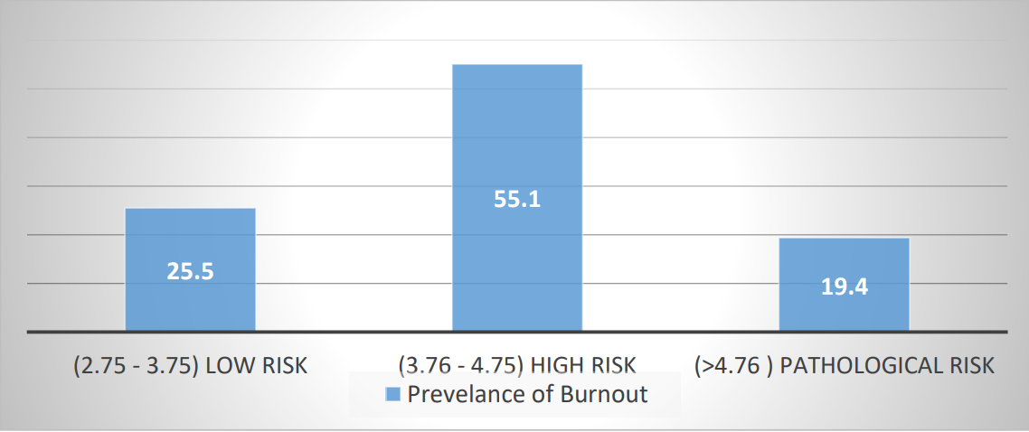

In our study, the four subscales of burnout (physical fatigue, cognitive weariness, tension and listlessness) of SMBQ were analysed which revealed that 64.4% of participants reported high physical fatigue as seen in the table below.

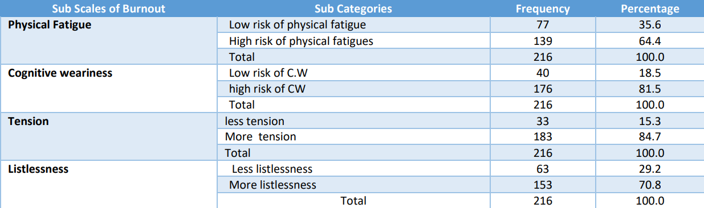

Association of Burnout with socio demographic characteristics and potential correlates: The prevalence of burnout was found significantly more among married bank officers (p =.014) as compared to unmarried bank officers. The bank officers living with nuclear family reported more burnout as compared to officers who were living in joint family arrangement (p =.010) which indicates that bank officers who were living in joint family have less chances of experiencing burnout .This finding in our study goes well with the importance given to family culture in our country. The 25.2% bank officers who lived with a small family size of up to four members experienced significantly more burnout (p = .002) as compared to officers living with a bigger family size . It shows that human relations plays a vital role in coping with work stress and could protect the employees’ health. When burnout was assessed among bank officers according to the occupational role, It was found out to be 6.7% in Probationary Officers, 23.4% in Bank officers followed by 22.1% in Managers and 24.1% in Senior managers .The risk of developing burnout is highest in chief manager followed by Assistant General manager, Officers, Probationary officers ( Entry level of Officers ). The risk of burnout was lowest in maximum probationary officers 53.3%. So, it is safe to say that based on this table, middle management of banks experiences the burnout most. The association between burnout and role of bank officers is found out to be statistically significant ( p = .016) which means one may experience burnout in their initial years of service as compared to later years.

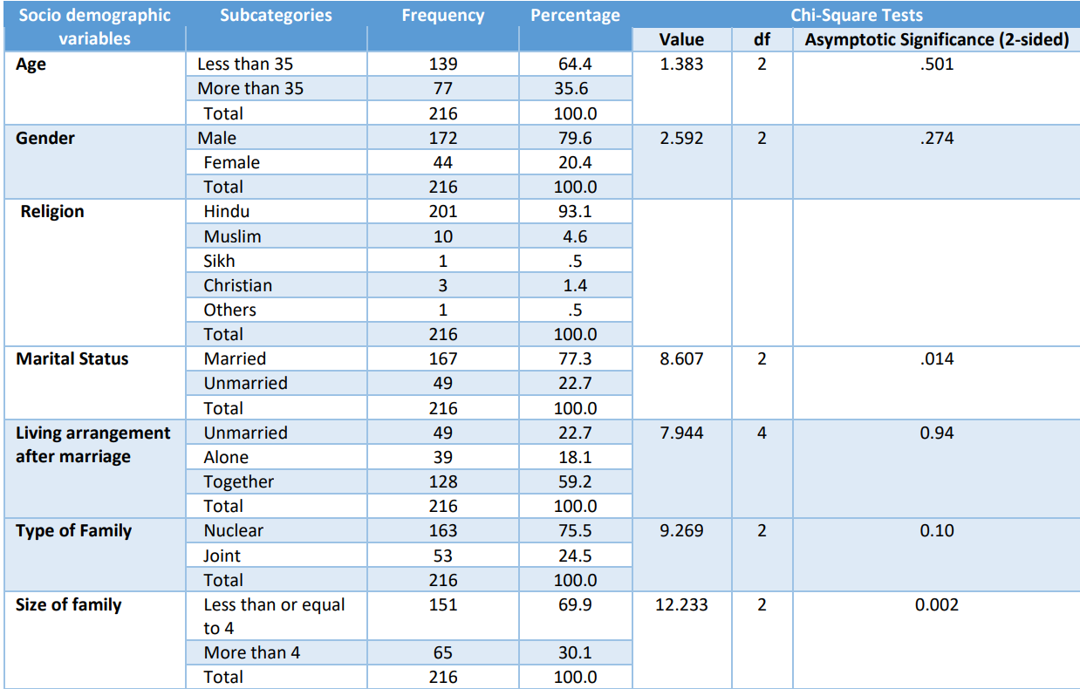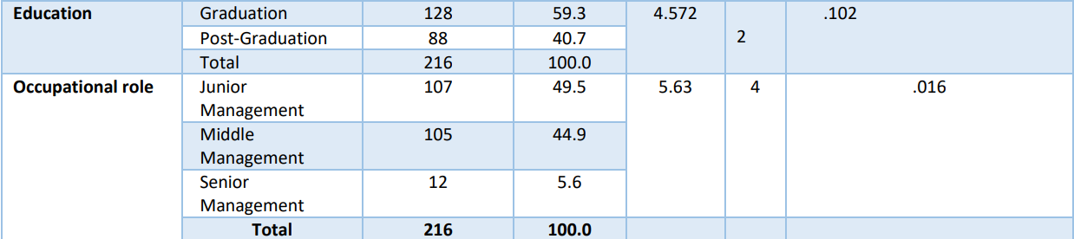

We have asked various risk factors in our survey responsible for burnout as seen in previous studies significantly related to workplace burnout . Insufficient time to relax in workplace is the most chosen factor by bank officers. The top 5 factors in our survey were found to be Body postures in workspace, Sedentary behaviour in office workspace, Bringing work related problems to home, Meeting tight deadlines at work leaves, Increasing privatisation and growing competition.

If a Bank officer is constantly exposed to the above factors, it can lead to burnout someday. More the exposure of above discussed factors higher will be the chance of facing Burnout.

When univariate logistic regression analysis was applied among all socio demographic characteristics family size, family type and marital status were found to be the most affected variable when there was one unit change in burnout.

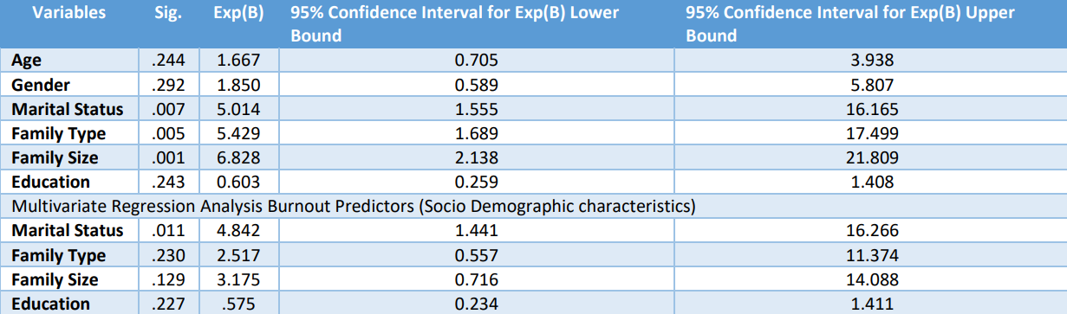

It shows that the risk of developing burnout was 6.82 times higher in officers living with small family size, 5.42 times higher in officers living with nuclear family and 5.01 times higher in married officers. When multivariate logistic regression analysis was applied among socio demographic characteristics in our study it evaluated one socio demographic variable at a time by nullifying other variable’s effect. It shows that the officers who were married were most prone to develop burnout.

**Discussion:**

Burnout is a gradual condition to develop in one’s life over a certain period of time, most of the studies conducted globally suggests that stress which can lead to burnout may come from all spheres of life, but majority comes from workplace(10) It is difficult to distinguish burnout at work from burnout in everyday life.

In this study, the four subscales of burnout (physical fatigue, cognitive weariness, tension and listlessness) of SMBQ were analysed which revealed that 64.4% of participants reported high physical fatigue.

Surprisingly the majority (85%) of bank officers scored high on cognitive weariness which suggests that in our study participants had more cognitive exhaustion than physical exhaustion responsible for burnout.

In this study burnout was experienced more in young age (upto 35 yrs) participants (21.6%) as compared to participants of above 35yrs of age group (15.6%) but the association was insignificant.

In the present study , the result of logistic (univariate) regression shows that family size (.001) has maximum impact on burnout followed by family type (.005) and marital status (.007) of bank officers. The bank officers who were living with smaller family size (up to 4 members) were 6.82 times more vulnerable to develop burnout as compared to those who were living with bigger family size and similarly, officers who were living in nuclear family arrangement had 5.42 times more risk to develop burnout than officers living in joint family.

**Conclusion:**

19.4% bank officers have pathological burnout followed by 55.1% of bank officers who are at the brink of developing burnout if no intervention is done with necessary preventive measures.

When sub - categories of burnout were examined among 216 bank officers, the highest prevalence was found of Tension (84.7%) followed by (81.5%) Cognitive Weariness, (70.8%) Listlessness and (64.4%) Physical Fatigue. Surprisingly physical fatigue was the least responsible factor of burnout in our study.

The prevalence of burnout was found significantly more among married bank officers ( 22.8%) as compared to unmarried bank officers (8.2%).

The bank officers living with nuclear family (23.3%) reported more burnout as compared to officers who were living in joint family arrangement (7.5%) which concludes that bank officers who were living in joint family have less chances of experiencing burnout .This finding in our study sits well with the importance given to family culture in our country.

When multivariate logistic regression analysis was applied among socio demographic characteristics in our study it evaluated one socio demographic variable at a time by nullifying other variable’s effect. It shows that the officers who were married were most prone to develop burnout.

**Recommendation:**

In order to identify and manage burnout at an early stage quarterly/biannually screening and assessment of burnout should be done in the bank. The focus should be on the risk factors at the workplace that pushes an employee to the edge of developing “high risk burnout” . Professional counsellors should be available on the panel of banks so that their services are easily available as and when needed.

**The need to make use of Mindfulness**

Mindfulness may appear wishy washy, but is a tested tool to overcome Burnout. Recent times have witnessed a “definite momentum change” with several global corporations employing mindfulness. Learning & Development leaders must give adequate attention to mindfulness because it makes their employees more effective. Mindfulness increases memory capacity, focus, effective decision making, and robust strategy formulation. It trains employees to use their prefrontal cortex, which allows them to make more measured responses in such a way that it adds value and reduces dissonance. Further, it allows employees to transition to a period of change more easily, more congruently, and helps them in coping with the rollercoaster of workplace stress.

Organisations are also making use of mindfulness to tackle stress and burnout, and at the same time, to increase employee performance. Google is one such example that offers mindfulness to its employees. Barclays, Citigroup, J.P. Morgan, Goldman Sachs and PwC have implemented Mindfulness programmes for their employees to overcome Burnout and improve mental faculties and workplace productivity. The length and breadth of practice research points towards implementing mindfulness.

A couple of years ago, top bankers in the UK have been advised to address the well-being of employees after an alarming report mentioned that several bank staff believed that their job was bringing down their health. In another study, a major chunk of the employees concurred that their firm has a negative impact on their health and wellbeing. Employees of too-big-to-fail banks reported that their well-being and quality of life was disturbed. This is the time for banks in India to underscore the value of implementing mindfulness interventions.

In view of the above, there is a compelling case for senior leaders of banks to empower their employees to overcome burnout and must keep the following pointers in their mind:

1. Leaders of banks need to take the issue of Burnout into cognisance rather than brushing them aside, and consciously address this psychological aspect

2. Learning & Development leaders of banks must make room for a minimum 2-day mindfulness intervention as a mandatory requirement for all employees

3. Specifically, bankers who are in the domain of strategic business operations must undergo mindfulness intervention, and experience a roller coaster ride with long and extended working hours.

4. Top management teams involved in strategic decision-making must have the benefit of mindfulness.

5. It must be acknowledged that mindfulness was developed as a systematic school of thought in the field of mental health, and hence qualified professionals must be engaged to implement these interventions.

6. Leaders’ role in creating a positive work culture such as managing work processes cannot be undermined, so that individuals and groups are neither overloaded not underloaded. Old fashioned practices such as eleventh-hour planning, endless meetings without meticulous agenda, unnecessary longer hours of working which hampers work-life balance must be consciously avoided.

7. To the maximum extent possible, policies should be in place to allow employee flexibility to work at the pace and manner that will ensure personal satisfaction while maintaining the much-needed productivity.

# 

# 

# 

# 

# 

# **Case study 2 : IT SECTOR**

**Introduction**

The IT industry is known for its stress levels due to high quality requirements in writing programs, testing the programs and proving it within a given period of time. Since the process is done to suit customer requirements, it is very important to identify the requirements and meet the expectation. These factors involve multi party engagement with the software employee, the senior and the people from the target organisation. So, the decision to postpone an activity or taking a sudden break for urgency will not be an easy option. Also, the employee needs to use his/her brain to a very high level of competency continuously in identifying the solution, people tend to break down due to stress levels and in turn lead to burnout in early life itself.

A trend known as tech employee burnout is becoming more noticeable in the tech industry due to expected high levels of productivity, long work hours, multitasking and constant exposure to computers and new technologies. Employee burnout in the IT sector refers to the extreme exhaustion and stress that many employees in the technology sector experience. Everyone has stressful days at work. But for some employees, it's not just once in a while when Monday rolls around; instead, stress is their daily reality. Over time, this can lead to full-on employee burnout. Burnout is especially common in the fast-paced, competitive environment of the tech industry. But how common is it, what are the consequences, why should we care and what can employers do to de-stress their workforce?

**Is burnout common in the tech industry?**

A study by mental well-being tool provider Yerbo found that two in five IT workers are at high risk of burnout, due to longer work hours and a more demanding workload. Additionally, another survey of more than 1,800 Salesforce professionals found that more permanent tech workers have experienced burnout in their role during COVID-19 compared to before the pandemic.

Likewise, 42% of IT workers who are facing high levels of burnout are considering quitting their company in the next six months, Yerbo found, while 62% of IT professionals report being "physically and emotionally drained".

Overall, one in four tech workers wants to leave their workplace in the short term, Yerbo's The State of Burnout in Tech report found. "The pressure of working against the clock to feed the global tech frenzy often forces employees to work late hours, leaving little time for personal life and creating work-life conflicts," said the researchers. These time pressures also force workers to resort to "short-term fixes to get the job done" – or 'antipatterns' – that ultimately lead to bigger problems and additional work later down the line. "When this happens day after day, allowing no space to recover mentally or physically, the ghosts of burnout – exhaustion, self-inefficacy, cynicism and depersonalization – start closing in," the report said.

**What Is Causing Employee Burnout in the IT industry?**

A survey found three top-cited factors for workplace burnout were unfair compensation (41%), an unreasonable workload (32%), and too much overtime work (32%). Other common factors included poor management, negative workplace culture, and employees feeling disconnected from the company strategy in their roles. Many of these factors are controllable if companies are honest and proactive about the issue.

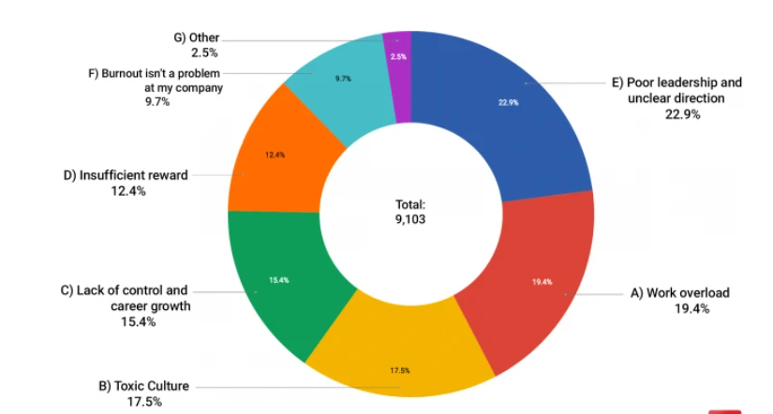

**Signs of burnout**

While there isn’t one universally recognised diagnosis for burnout, most definitions warn of similar symptoms. These include being cynical and short-fused, a loss of empathy, lack of energy, having trouble sleeping and increased absenteeism or presenteeism.

Dr Veerle van Tricht, a surgeon and burnout expert, lists these symptoms among others as signs to look out for. She says that, aside from the moral reasons to look after the health of employees, missing signs of burnout can have a knock-on effect for your organisation.“If you exhaust your workers, they will make mistakes and it will rub off negatively on your reputation and that of your company,” she says. “For me, it’s a no-brainer to make sure everybody is happy and healthy at work. It’s unfeasible for the human body to go without eight hours of sleep in the long run. “When people are unwell, you should be tolerant and more humanly flexible to people’s circumstances. If your boss doesn’t care about you, you won’t care for your boss either.”

If you're suspecting that the employees are struggling with burnout, here are the signs to look out for:

* High turnover: an increase in your turnover rate is a possible signal of burnout. It might suggest that your employees are tired and looking for more rewarding opportunities elsewhere.
* Reduced performance: burnout employees would have difficulty concentrating, lacking creativity, and failing to meet requirements. You will notice an increase in bugs, glitches, bad code, and extended deadlines.
* Increased absenteeism: burnout often portrays itself in unhappy employees who tend to take many sick days. Even though they're not feeling ill, they take "sick" days just to get away from overwhelming projects.
* Poor internal relationships: if you notice your employees get into negative conflicts with their coworkers, this might be another sign of burnout.
* Low morale: overworked employees often have more negative, impatient, and cynical behaviour. The negative work environment is contagious and can quickly affect everyone on the team.

**The Consequences of Burnout in IT sector**

Burnout has serious consequences on both the micro and macro levels. In healthcare spending alone, workplace stress costs $125 to $190 billion annually. It contributes to around 120,000 deaths per year.Stress is also responsible for higher rates of quitting or job-changing among employees: 95% of HR leaders agreed in the Kronos survey that burnout was sabotaging workforce retention.

James Campbell Quick, Ph.D., has produced much research regarding occupational stress and burnout, examining it from both the individual and organisational levels. He emphasises that there are also financial consequences for companies who ignore the mental health of their workforce."There are huge, if sometimes hard to calculate, financial costs associated with poor mental health at work," Quick says. "The US Air Force HR team at one logistics depot of 13,000 employees estimated that there were over $33 million in costs avoided because the commanding general had hired a full-time psychologist."

This is the question that Blind—a workplace app for tech employees—set out to answer through a user survey.The app is used by 40,000 Microsoft employees, 25,000 from Amazon, 10,000 from Google, 7,000 from Uber, 6,000 from Facebook, and thousands from other tech companies, so there is wide representation in their survey results.

The one-question survey had a simple yes/no answer: “Are you currently suffering from job burnout?” And over half of respondents (57.16%, to be exact) answered yes.

Some companies had more burnout than others in the survey. Credit Karma had the highest rate, with over 70% of employees saying they were burnt out. Netflix was the lowest at around 39%. But when the best company in the survey still has a nearly 40% burnt-out workforce...the tech industry might have a problem.

**How can we reduce employee burnout in the IT sector?**

It’s obvious why employers want to foster engagement, but few know how to foster high engagement and high well-being at the same time. Employee well-being drives engagement, and vice versa. When employees are engaged in their work, they feel good and live with a sense of purpose.

Employees with higher well-being are twice as likely to be engaged in their jobs. Research by Limeade and Quantum Workplace shows these employees enjoy their teams more, are more loyal and recommend their company as a great place to work. Further, highly engaged employees with high levels of well-being are able to cope with higher levels of stress without succumbing to the symptoms of workplace burnout.When employees have high well-being AND feel supported by their organisation, it’s a win for everyone.

Employees who are completely burned out have lost sight of meaning in their work. Managers and organisations must recognize burnout and help re-establish meaningfulness in employees’ lives and work. Employee burnout is real and it’s affecting millions of workers globally. It’s imperative that companies understand the impact burnout has on employee engagement and business results — and know the tools and strategies for how to reduce burnout in the workplace. It’s up to organisations (and managers) to spot signs of burnout and intervene as quickly as possible. Companies should strive to prevent workplace burnout in the first place by focusing on employee well-being and manager support. When employees are burned out, companies and managers need to take an active role in helping the employee recover. Burnout is not a personal issue, it’s an organisational issue. Burnout needs to be addressed at all levels of the company in order to effectively prevent and combat it.

The good news is that burnout is preventable. With strong manager support and an understanding of what causes job burnout, employers can more readily prevent their top talent from burning out.

Here are the ways managers can help prevent burnout at work:

1. Role clarity

Only 60% of employees know what's expected of them at work. This can create confusion, low-quality work, and missed deadlines. Your employees can get tired and overwhelmed by simply trying to understand what they're supposed to accomplish. Make sure you always provide details for the task that needs to be completed and give your team a chance to ask questions.

1. Communication and support

Ongoing communication and support from a manager are critical. Employees who feel supported by their managers are 70% less likely to experience burnout regularly. Hold regular meetings, weekly check-ins, and collaborate via apps such as Slack and Asana. If you're leading a remote team, use a team management tool like Google Hangout to hold virtual meetings with the team.

1. Reasonable deadlines

The study found that when employees have a sufficient period of time to do their work, they're 70% less likely to experience burnout. Make sure your software developers are always given an adequate amount of time to finish their tasks.

1. Positive work environment

One way of making employees feel like valued members of the company is by creating a positive work environment. You should:

* Promote collaboration.
* Reward employees for their work.
* Be transparent.
* Support diversity.
* Offer opportunities for learning and development

1. Work flexibility

Did you know that 82% of Millennials said they would remain more loyal to their employers if they had more flexibility at work? Or that they are willing to give up a percentage of their salary for flexible office hours? Many tech companies have begun offering flexible work options to their employees in the form of remote work, part-time work, or telecommuting. Flexibility comes with many benefits for employees, including:

* More time off of work.
* Plan their own schedules.
* Work from home when needed.
* Travel and work at the same time.
* Spend more time with the family.
* Have work/life balance.

1. Work benefits

According to StackOverflow, 18% of developers said that compensation and benefits were one of the most important things they consider about any job opportunity. The best benefits you can offer to your overworked employees include:

* Good health insurance.
* Healthy food on-site.
* Gym membership or fitness classes reimbursement.
* Nap rooms.
* Stress management workshops.
* Entertainment rooms.

1. Access to counselling

Another way of preventing employee burnout is by offering access to counselling. It can be on-site with a professional counsellor, or it can happen online via mental health apps like Talkspace or What'sApp. Ongoing one-on-one therapy can help an employee with their low productivity levels, increased absenteeism, and tense relationships with coworkers.

**Summary:**

An overall study of various literatures points to a serious problem happening to organisations as well as individuals due to burnout. In the organisations, the most common factor which is cited as the main cause of burnout is work overload. It is common in the IT industry to have the employees overloaded with work when the company gets any contract and sometimes employees sit in benches without any work for weeks waiting for the next work to land in. Hence, this is a unique pattern which is not common in other industries because when the employees are seeing a zig zag work allocation it affects them badly. Another important factor which was visible in the literature was the age factor. Due to continuous pressure in work and in personal life, once the employees are becoming old, they tend to be more prone to burnout. Apart from this, it is commonly found that there is always role ambiguity and role conflict. Clarity of the role played by the employees is not visible in most of the organisations and due to this issue employees are not able to give the expected output as they work in different job profiles within organisations. Overall, from various literatures there seems to be a great opportunity lying ahead in studying burnout in IT industries.

Burnout in the tech industry often goes unaddressed. Many overzealous professionals practise a strict adherence to grind culture in order to meet deadlines and fulfil project requirements. But it’s never healthy to deprioritize your mental health just to meet corporate goals. And in fact, it can be counterproductive, as work performance usually dwindles due to burnout.

If you’re experiencing the symptoms of burnout, it’s your body’s way of telling you that all is not well, and something needs to change. Thankfully, stress and burnout are remediable, and acknowledgement is the first step to dealing with it.

# 

# 

# 

# 

# 

# 

# 

# 

# 

# 

# **Case study 3 : HOSPITAL**

**Introduction**

The importance of burnout as a variable of concern in a health care delivery setting has been significant because it affects service quality and care rendered, job performance, absenteeism, turnover, morale and psychological well-being. It has been observed that burnout leads to tiredness, non-involvement and loss of effectiveness. Further, it has been associated with negative consequences for patients, institutions and, especially the medical personnel involved. Such consequences in healthcare settings could be detrimental to healthcare personnel as well as to patients being treated.

Burnout manifests in individuals, but it’s fundamentally rooted in systems. And health worker burnout was a crisis long before Covid-19 arrived. Causes include inadequate support, escalating workloads and administrative burdens, chronic underinvestment in public health infrastructure, and moral injury from being unable to provide the care patients need. Burnout is not only about long hours. It’s about the fundamental disconnect between health workers and the mission to serve that motivates them.

**Pandemics**

During the current COVID-19 pandemic, closing down of international and state borders, strict city, and also areawise lockdown has affected HCWs and their families as well, causing excessive negative psychological effects. Burnout, a state of “emotional exhaustion” among professionals, was first described in the mid-1970s, by Freudenberger and Maslach.

Burnout is defined as a state of physical, emotional, and mental exhaustion that results from long-term involvement in work situations that are emotionally demanding. It is a multidimensional syndrome comprising emotional exhaustion, depersonalization, and reduced sense of personal accomplishment.

In the past two decades, several viral outbreaks have occurred, such as SARS, MERS, Ebola, etc. Kisley et al. in a recent review reported that such outbreaks resulted in psychological distress and posttraumatic stress in the HCWs. Of the many causative factors described by Kisely et al., clinical factors (contact with affected patients, forced redeployment to look after affected patients, training perceived to be inadequate), personal factors (fear of quarantine, particularly in staff with children at home, and infected family member), and societal factors (societal stigma against hospital workers) seem to be particularly relevant in Indian healthcare scenario. Burnout, apart from being personally harmful, can lead to suboptimal patient care.

The novel coronavirus disease 2019 (COVID-19) pandemic has resulted in an overall surge in new cases of depression and anxiety and an exacerbation of existing mental health issues, with a particular emotional and physical toll on health care workers.Limited resources, longer shifts, disruptions to sleep and to work-life balance, and occupational hazards associated with exposure to COVID-19 have contributed to physical and mental fatigue, stress and anxiety, and burnout.Similar to most hospitals in the COVID-19–affected areas, system has experienced an overwhelming impact of this pandemic on personnel.

Physicians and nurses are worried about their families, and some hesitate to go home in fear of exposing family members to infection. It is common to see emotional exhaustion in the intensive care unit (ICU). We have observed front-line health care providers emotionally breaking down, mainly due to the added pressure to choose between family responsibilities and their inner sense of duty toward patients.

At the same time, we have seen an overwhelming influx of support from medical leadership, public and private acknowledgments, community support (eg, food sent to care units), as well as additional services offered to staff, such as music therapy, counseling services, chaplain services, and accommodations in work schedules. Other organisational adaptations include allocation of more resources (eg, float nurses, physicians, patient care assistants, and new equipment). Moving forward, our institution has plans for marshalling resources from surgeons, anesthesiologists, other medical specialists across all disciplines, and, in extreme circumstances, anyone with medical training and background.

**Specific occupations at risk**

1. **Physicians**

In these days of faltering systems of medical care that are being subjected to a multiplicity of new designs, physicians are finding their chosen occupations being attacked from many fronts, causing the practitioners to question their choice of careers.

Medicine attracts idealists who want to help others, but as professional demands increasingly impose on their available time and energy, more is crowded into the limited work day. The support which has been granted physicians in the past is not at hand

Many of the practitioners are far from their families and hometowns, a great number settling in the area of their education and training. Their interactions are with patients who are in pain, sick, or frightened. Rarely is a thank-you proffered from a patient, practice is competitive, and the emphasis is on achievement, and the threat of a malpractice suit, often suggested by a too-eager attorney, constantly hovers over the physician, particularly one whose speciality is surgery or obstetrics. Premiums for such protective insurance are extraordinarily high. After a suit, be it won or lost, the defendant is depressed, frustrated, less satisfied with the practice, and subsequently many consider early retirement

There is great pressure on physicians, particularly in light of today's pace in technologic developments, to 'keep up'. This effort has to be balanced against family life. Further, there is genuine fatigue as a by-product of a busy practice; most practitioners share 'on-call' duty — which means contact with patients whose progress or treatment plan is unknown; work loads are heavy; there is a daily dealing with life and death situations; decisions concerning the maintenance of impaired living vs. 'do-not-resuscitate' orders are difficult to make; and, lastly, there are the constant interruptions at the office, the hospital, and the home.

Working in an intensive care unit (ICU) environment is known to be stressful. For all ICU healthcare workers more than the physical work, it is the psychological factor of dealing with the seriously ill patients which leads to huge mental stress. This includes discussion with patient family and relatives about the risk of death, to disclose deaths especially in an unexpected situation and to discuss end of life issues. This stress when persisting for quite some time can lead to burnout, which in turn can cause a decreased personal well-being, increased absenteeism, more mistakes and ultimately compromised patient care

1. **Nurses**

Nurses, in a manner similar to physicians, undergo repetitive and continuing exposure to the ill, the dying, and death. Whereas physicians' contacts are intermittent and shorter in duration, nurses are in attendance of their assigned patients throughout eight-hour and, frequently, twelve-hour shifts. There has always been work overload in this profession and, in many hospitals in isolated areas, overloading has increased in the form of double shifts. The popularity of extended shift hours has been increasing despite indications that most 12- hour nurses report fatigue.

Patients can be demanding and often communication with caring nurses is dulled or negligible because of overriding medication, precluding any feeling of gratification derivable from an ailing person.

With the frequent calling in of nurses from centralized registers, the registered nurses (RN) or licensed vocational nurses (LVN) may find themselves working with different teams from day to day following transfer from one hospital service to another or one hospital to another, where communication with the newcomer may break down in the harried provision of care, or where they may be no support of the newly-come professional.

1. **Emergency service personnel**

Whether the workers in emergency services are physicians, paramedics, emergency medical technicians (EMT), or specially trained firefighters, they are subject to being called to physical catastrophes presenting emotionally taught, high-risk situations. All are expected to be able to respond quickly and appropriately in life-and-death circumstances.

1. **Other professionals**

Burnout has been experienced by health care workers in other speciality areas. Nurses employed in relatively small nursing homes, where there is a high probability of the residents' deaths, are under stress. Job stress has been described, as has burnout, among rehabilitation practitioners, and also among nurses in critical care. Workers in the neonatal intensive care unit have experienced burnout, for 15-20% of admitted infants die, and nurses in a sense become surrogate parents, taking care of high-risk babies from high-risk families. Occupational therapists have had comparable brushes with burnout.

**Identification**

In the analysis of any troubling situation, it is important that the problem be identified, and as early as possible, to facilitate its ultimate resolution. Familiarity with the signs and symptoms of burnout among health care workers should be one of the lead bodies of knowledge among supervisors. Group directors should be able to detect the effects of stress not only through observation of work performance but through the accumulation of information gathered from other workers and from patients, many of whom are highly verbal in their reaction to impaired handling.

A worker's behaviour can change markedly when under continued pressure, and these changes must carry meaning to the supervisor. Not all signs are verbal signals., for much of the evidence of burnout in professionals is to be seen in the quality of care provided and, if possible, in a review of therapeutic outcomes. Hardening toward clients or patients must be identified not only to effect a reversal of behaviour but for the ultimate good of the organisation.

Employees' records should be reviewed periodically to determine any excessive absenteeism, tardiness, or inordinate use of sick leave, or other evidence of a wish to leave the job, as seen also in unnecessary wandering from the customary work station. An unwillingness to work with a staff member who is undergoing burnout may be expressed by fellow employees in whom dedication to the mission is still paramount. While such feelings may not emerge through direct verbalization, tendencies toward non co-operation can be detected by a sensitive supervisor. While a manager is usually inclined to defend a staff person when attention is directed to a work error, patients or clients should be heard to the fullest if a complaint has been raised. Not all recipients of care are to be dismissed as unknowing of, or insensitive to, inadequate treatment or harried inattention.

Every grievance must be given a hearing, for behind some of the dissatisfaction felt may be a worker in the process of undergoing emotional loss or behavioural flattening, and no longer able to provide effective care.

**Prevention and treatment**

It is difficult to distinguish readily between measures preventive of burnout and efforts taken to treat the disorder. If preventive measures are in place, burnout will not occur; if the behavioural disorder is already in place, the same preventive moves may be used therapeutically.

Group or staff discussion meetings are essential to increase communication among members of a work unit, be it a small group or a division. The unit chief should serve as chair, discussion leader, or facilitator, but he or she must be able to allow free interchange of ideas and be tolerant of expressed negative feelings concerning his or her style of management.

In a similar vein, the initiation of critical incident stress debriefing (CISD) in law enforcement, essentially a discussion allowing the free flow of feelings after a traumatic event — a chase, a shooting, a death — will allow a return to work without the accompaniment of lingering reactions of guilt, inadequacy or inefficiency. The debriefing after negative outcomes permits the communication needed for resumption of duties after an extremely stressful experience.

These staff meetings must be characterised by an air of permissiveness of the expression of ideas, complaints, suggestions or questions, without the fear of retribution, punishment, delayed promotion, or any negative action by the supervisor. Also, the meetings should be held expressly for exchange and not merely for the supervisor to announce predetermined decisions concerning significant issues. Further, if ideas are offered that could prove remedial of current problems, action should be taken by the immediate manager, so that participants in these sessions will know there is follow-up to proffered points of view.

Apart from maximising communication through group sessions, feelings of managers can be extended to workers so that they become cognizant of the value or worth of what they are doing. Probably of greatest importance in the prevention of burnout among valued professionals is the increased control of individual jobs, or the granting of greater autonomy in what one does daily. As expressed by writers cited earlier, one must 'redesign jobs to enrich the work and to rejuvenate [the] staff. Efforts in this area have been seen in the creation of work circles where employees have a greater say in their jobs.

**THE FUTURE**

One of the preventive measures to be utilised in the aborting of burnout among health care workers, or any workers, is the institution of much more careful, earlier vocational counselling. Such counselling in today's schools is minimal, at best. It is needed for such reasons as matching the physical and emotional capacities of a potential caretaker with the demands of the position sought, and detecting early career choices that are parent-driven and not candidate selected.

Even though the Act for Disabled has brought many limited or impaired persons into the workforce, there still are great numbers of physically and emotionally demanding jobs in health care, so that careful placement is mandatory.

One additional view of the future must be considered. Life is more than an eight-hour workday, and at some time in the future, one must return to living without the exercise of the vocational skills acquired in school and honed at the workplace. Much of today's preparation of health care personnel is via training and not through education. One is broadened by a learning programme that touches on the arts, on different cultures, on the world's history, and the like. There must be a fuller life to which one can turn when the repetitive cycle of work days has slowed. Many individuals — in health care -- look forward to postretirement leisure, only to learn that they are ill-prepared to extract from the time remaining, the emotional, mental, and spiritual joys they had anticipated. Were there an educational preparation beyond the technical honing, life would be fuller for those who have given much of themselves to a career, always with the potential of a terminal burnout.

Will the 21st century see a lessening or an increase in burnout among health care workers? Only when the method of providing care moves from dissolution to resolution will the answer become available.

**SUMMARY**

Burnout is a professional occupational disease manifest in the many specialties of health care and will be a disorder as long as human values and worth are disregarded by inept policy makers and managers of human resources. In the end, the elimination of burnout will mean better care for clients and patients.

Herbert Freudenberger, who brought the concept of burnout to professional and public awareness in 1973, cautioned a few years ago that, 'We also need to incorporate a sense of spirituality in our work. I do not mean institutionalised religion, rather a sense of morality, ethics, shared values and beliefs. Values should help to promote the human good, and help us face frustration, sadness, stress and ultimately death. We need to develop ways and means, like a good relay team, to pass our knowledge of how to prevent burnout on to the next team, so that they will benefit from our errors and not become enmeshed in the same difficulties.

# **AVOIDANCE**

During periods of uncertainty, employees are more likely to experience stress at work, which can lead to burnout. It’s vital that managers regularly check in on their direct reports and ensure they’re getting the support they need, both as employees and as individuals. High-impact roles that often work in silos, like tech roles, require additional supervision to [manage employee engagement](https://builtin.com/employee-engagement/how-to-engage-employees) and avoid burnout.

Below are some ways to avoid employee burnout:

### Give frequent and actionable feedback

Give and collect feedback during regular [one-on-ones](https://builtin.com/people-management/one-on-one-meeting-check-ins) with your direct reports to avoid burnout in the workplace. This helps build a stronger manager-employee relationship and provides individuals with a private opportunity to discuss challenges they’re facing. Provide employees with feedback they can use to improve in their role. Both [constructive criticism](https://builtin.com/career-development/constructive-criticism) and praise have a positive impact on engagement. Also, ask team members for feedback; listen to their concerns and brainstorm ways to improve communication and enhance their employee experience. [More than half](https://www.gallup.com/workplace/357104/ways-managers-stop-employee-turnover.aspx) of employees who leave their jobs say their manager or organisation could have stepped in to prevent such a decision. As a result, it’s crucial managers ask their team members for their input and take action accordingly to help mitigate [voluntary turnover](https://builtin.com/recruiting/cost-of-turnover).

### Prioritise wellness and mental health

It’s difficult to maintain work-life balance in a digital world where we’re always plugged in, but it’s even harder for remote employees whose home life and office overlap. Encourage your direct reports to take time for themselves as needed. Remember that each individual is unique and will require different forms of support to stay [physically and mentally healthy](https://builtin.com/people-management/mental-health-stigma). Allow your team to take advantage of the wellness opportunities offered in your employee benefits package as a way to boost your company culture and prevent burnout.

### Normalise taking breaks

Some employees will be hesitant to unplug out of fear of missing an update or falling behind. Implement different activities into your team’s routine that offer a mental break from the grind. Incorporating wellness activities into the workday ensures employees know it’s OK to [take time to recharge](https://builtin.com/people-management/sabbatical-leave). Acting critical of their need to do so is not conducive to a healthy and supportive work environment, and can actually cost your organisation money — [60 percent](https://www.businessolver.com/who-we-are/news/businessolver-finds-workplaces-still-lack-empathy) of employees would take a pay cut to work for an empathetic employer that recognizes the consequences of job burnout.

### Set and maintain realistic expectations

Nothing will demotivate and disengage an employee faster than unattainable goals. Feeling like they’re chasing after a moving target and constantly missing the mark will shatter an employee’s self-confidence and potentially lead to workplace burnout. Goals should be both progressive and flexible; you shouldn’t expect a new hire to perform at the level of a two-year-tenured employee.

### Improve your onboarding process

Your onboarding process is an employee’s first real introduction to your company, and a strong onboarding sequence sets employees on the path to success. According to a Glassdoor survey, employees are [18 times more likely](https://www.glassdoor.com/employers/blog/ongoing-onboarding/) to feel a commitment to their company if the onboarding process meets their expectations, and 49 percent of employees are then able to contribute during their first week. It’s a manager’s job to give employees the tools they need to thrive in their role, and that means clearly outlining their responsibilities and objectives. If employees know what’s expected of them, they’re more likely to take pride and invest in their work while setting boundaries to avoid burnout.

### Offer flexible scheduling

Giving employees the freedom to adapt their working hours to their personal lives has a positive impact on engagement. Not only does it help them establish a work-life balance that meets their needs and helps prevent burnout, it also gives them a sense of autonomy, which enhances their overall employee experience.

### Make time for fun

Engaging social initiatives should already be in place as part of your company culture, but you can implement additional activities specifically for your team. Doing so helps employees bond as a collective unit and on a personal level. It also helps them blow off steam at the end of the work day and relieve stress to avoid burnout.

### Offer rewards

In addition to recognizing employees for a job well-done, give them a reward for their efforts. Incentives and prizes are common among sales teams, but also work well in motivating and engaging employees across all departments. Offering rewards makes employees feel appreciated and encourages them to take pride in their work.

# **SURVEY ANALYSIS**

The survey conducted contains questions to analyse the employee performance of job. The employee sometimes overwork out due to completion of tasks. The survey got 100 responses and the general consensus is presented below with graphical representation.

From the survey we can analyse that overall big industry employees suffer from employee burnout. A generalised analysis of the same is shown below.

* **Do you enjoy your work?**

We can say from the survey that people have different opinions about the enjoyment of their work. The ones who say yes thoroughly like their jobs. There are some people who enjoy their work depending upon their task. some which enjoy work very rarely & also people who never enjoyed their work.

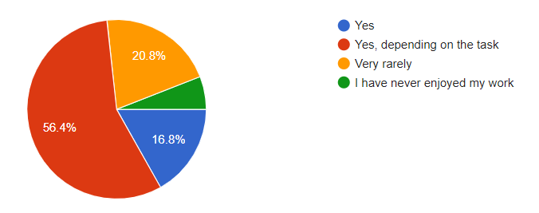

* **Do you feel that you and your work are adequately appreciated?**

By analysing the survey some employees working in the company say that they feel adequate about their work appreciation. Some people say sometimes their work is appreciated. Some feel they are inadequate about their work.

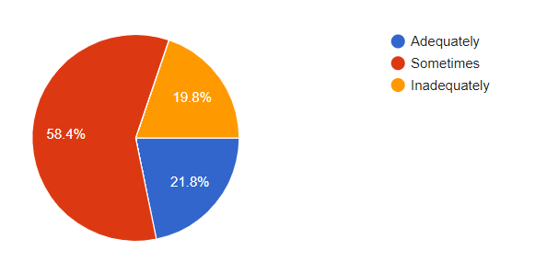

* **Are you beginning to feel complacent at work?**

The meaning of complacent is showing smug or uncritical satisfaction with oneself or one's achievements.

Some employees feel complacent about their work. Some employees feel complacent about their work.

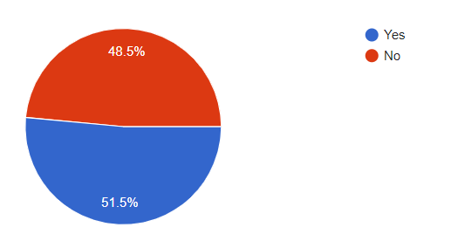

* **Do you suffer from a sleep disorder of any kind?**

Due to high workload in the big companies & the very short timelines to complete every task. So from the survey most employees sometimes get sleep disorders. Some employees often experience sleep disorders due to high working load. Some employees have the opinion that they don’t experience sleep disorders.

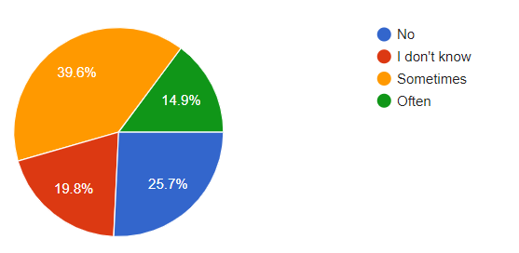

* **Do you feel you work more than you should?**

According to a survey most of the people work overtime as they work more than they regularly should do. Some don't think they work more than they should. Some employees sometimes work more than they should.

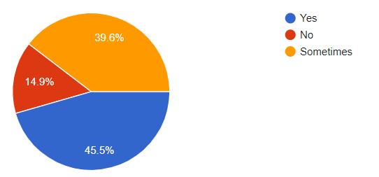

* **Specify the number of hours spent on working.**

From the survey we got to know that most employees work around 40 - 80 hours per week. Some employees also work more than 80 hours. Employees who work more than 80+ hours experience sleep disorder syndrome. They work more than they should do like other normal employees who work around 40-60 hours weekly.

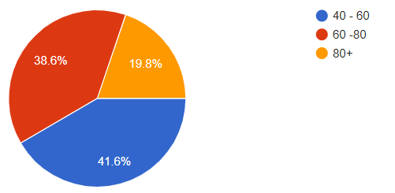

* **Do you ever feel you have burned-out at work before?**

Due to high working hours & sleep disorder the employee working capacity degrades as time grows. So employees don't get proper sleep & work tirelessly without any rest.

So according to a survey most of the employees are burned out of workload & other people are not burned out because of work.

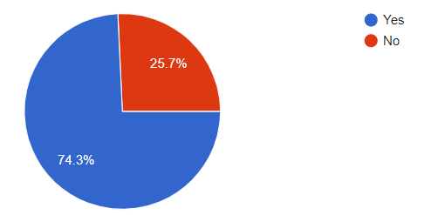

**CONCLUSION**

We must admit that widespread and increasingly serious job burnout is a complex and difficult problem for enterprises to address during any epidemic. This study explored the safety behaviour mechanism of COVID-19 under the influence of two important psychological factors. The results of this study show that job burnout will negatively affect the work of employees and increase the possibility of unsafe behaviours among employees, which will have adverse impacts on the safety status of employees. However, in the process of preventing and controlling COVID-19 in enterprises, psychological contracts can weaken the potential for unsafe behaviours by employees due to job burnout. If the organisation attaches importance to the establishment of emotional trust and effectively connects employees with the organisation, it can ensure the conscious and good implementation of epidemic prevention and safety behaviour.

In order to address COVID-19 or other similar public health crises, enterprises can provide material resources and social support for employees to alleviate their job burnout. For example, different support projects and activities can be carried out to alleviate the negative emotions of employees, form an organisational atmosphere of humanistic care, and improve employees’ positive work emotions. This helps them to build a sense of trust and belonging at work and to better perform safe behaviour.

However, there are some deficiencies in this study. First, since our cross-sectional study is based on survey data during a large-scale infectious disaster, the conclusions need to be confirmed by prospective cohort studies. Therefore, we suggest that a longitudinal design should be used in future studies to evaluate the research findings. Second, the universality of the conclusion needs further demonstration.

Employee burn has adverse effects on employee engagement and retention. By improving the employee experience, organisations can systematically target burnout. The employee experience encompasses an employee's entire journey with their organisation. It encompasses all of an employee's interactions with the organisation throughout the employee life cycle. From the culture of the organisation to employee engagement programs, most employees at this point are looking for meaning and personal growth from their work. If you are looking for interesting ways to engage your employees then we suggest you check out employee volunteerism for your employees. Engaging your employees in volunteering programs can help boost their morale, and give them a sense of belonging and purpose.

**APPENDIX**

The following questions were included in the survey for the analysis. The survey received 105 responses and the detailed analysis has been shown in the report. The survey was conducted to gauge the relevance of the report.

1. What is your gender?
2. Are you satisfied with your current job?
3. Do you enjoy working on the job?
4. Do you feel that you and your work are adequately appreciated?
5. Are you beginning to feel complacent at work?
6. Do you suffer from sleep disorders because of working?
7. How many hours do you work weekly?
8. Do you feel you work more than you should?
9. Do you ever feel you have burned-out at work before?

# **REFERENCES**

# <https://humancapitalonline.com/learningdevelopment/details/631/burnout-in-bankers>

# <https://www.researchgate.net/publication/362511711_Job_Burnout_Assessment_Among_Officer_Grade_Bank_Employees_of_Meerut_District/link/636a49812f4bca7fd040b6dd/download>

1. <https://academic.oup.com/occmed/article/48/4/237/1423532?login=false>
2. [https://academic.oup.com/heapol/article/31/5/551/2355444?login=false#55952669](https://academic.oup.com/heapol/article/31/5/551/2355444?login=false%2355952669)
3. <https://journals.lww.com/anesthesia-analgesia/fulltext/2020/07000/provider_burnout_and_fatigue_during_the_covid_19.17.aspx>
4. <https://www.survio.com/survey-template/employee-overburden-and-burnout-survey>
5. <https://builtin.com/employee-engagement/employee-burnout>

# **GLOSSARY**

# **Exacerbation:** Worsening

# **Influx:** A large number of things or people arriving suddenly

**Suboptimal:** Of less than the highest standard or quality

**Precluding:** to prevent something from happening or somebody from doing something; to make something impossible

**Proffered:** hold out or put forward (something) to someone for acceptance.

**Cognizant:** having knowledge of something

**Inept:** not able to do something well

**Enmeshed:** involve (someone) in a difficult situation from which it is hard to escape

**Complacent :** showing smug or uncritical satisfaction with oneself or one's achievements.